EXPERIMENT – 07

DSA.

Name : Bhavesh bonde

Roll no : 06

Batch : S1

Code :

#include <stdio.h>

#include <stdlib.h>

int source,v,e,time,visited[20],g[20][20];

void DFS (int i)

{

int j;

visited[i]=1;

printf("%d ->",i+1);

for(j=0;j<v;j++)

{

if(g[i][j]==1 && visited[j]==0)

DFS(j);

}

}

int main()

{

int i,j,v1,v2;

printf("\t\t\tGraphs\n");

printf("Enter the number of edges:");

scanf("%d",&e);

printf("Enter the number of vertices:");

scanf("%d",&v);

for(i=0;i<v;i++)

{

for(j=0;j<v;j++)

g[i][j]=0;

}

for(i=0;i<e;i++)

{

printf("Enter the edges in format:(v1,v2)=");

scanf("%d%d",&v1,&v2);

g[v1-1][v2-1]=1;

}

for(i=0;i<v;i++)

{

for(j=0;j<v;j++)

printf("%d",g[i][j]);

printf("\n");

}

printf("Enter the source:");

scanf("%d",&source);

DFS(source-1);

return 0;

}

Output :

I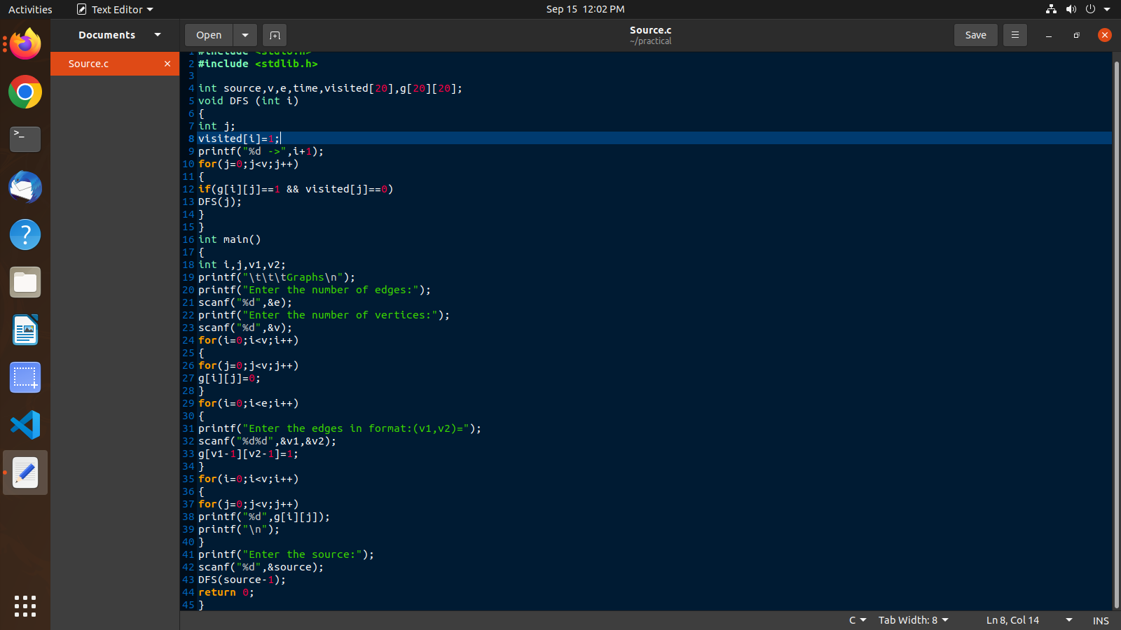

_1

#include<stdio.h>

#include<stdlib.h>

int a[20][20],q[20],visit[20],n,f=-1,r=-1;

void bfs(int v)

{

int i;

for(i=0;i<n;i++)

{

if(a[v][i] !=0 && visit[i]==0)

{

r=r+1;

q[r]=i;

visit[i]=1;

printf("%d",i);

}

}

f=f+1;

bfs(q[f]);

}

int main()

{

int v,i,j;

printf("\n Enter no. of vertices: ");

scanf("%d",&n);

for(i=0;i<n;i++)

{

visit[i]=0;

}

printf("\nEnter graph data in matrix form:\n");

for(i=0;i<n;i++)

for(j=0;j<n;j++)

scanf("%d",&a[i][j]);

printf("\nEnter the startung vertex: ");

scanf("%d",&v);

bfs(v);

if(r!=n-1)

printf("\nBFS not possible");

printf("\n");

return 0;

}

I_2_output 